Chhotubhai Gopalbhai Patel Institute of Technology
Department of Automobile and Mechanical Engineering

A Report of one day workshop
On
“Perspectives on Advanced Material Technologies”
Title: | Perspectives on Advanced Material Technologies - 2016
Organizing Department: | Department of Automobile and Mechanical Engineering
Chief Patron: | Dr. D.R.Shah, Provost UTU.
Patron: | Dr. N. C. Shah, Director, CGPIT.
Convener: | Dr. Chinmay Desai, Professsor, Head of the Department,  Department of Mechanical/Automobile Engineering, CGPIT
Organising Secretary: | Mrs. Palak Desai, Assistant Professor  Mr. Umang Patel, Assistant Professor
Organising Committee: | Mr. Lalaji Godhani, Assistant Professor  Mr. Urvin Patel, Assistant Professor  Mr. Haresh Ghoniya, Assistant Professor  Mr. Sajan Joshi, Assistant Professor  Mr. Harshit Desai, Assistant Professor  Mr. Mayur Patel, Assistant Professor  Mr. Deep Parekh, Assistant Professor
Institute: | C. G. Patel Institute of Technology, Bardoli.
Targeted Audience: | Students, Faculty member and Industrial Persons
No. of Participants: | Students: 220  Faculty members: 61  Industrial persons: 2  On the spot registration: 00  Total: 283
Date of Event: | 17th September 2016
Invited Speakers: | Dr. P. B. Joshi  Dr. Vandana J. Rao  Dr. Rakesh K. Sharma

Details of Workshop:
Development of new materials makes the standard of leaving of human being better. Selection of a right material is often the forerunner to the step wise progression of a technology. Advanced materials especially lightweight materials are at the heart of commercial and military purpose. The challenges of the next generation are complex in nature, but these challenges will overcome through developments and application of new or improved materials. This workshop aims at giving overview of advances in materials.
The first lecture was of Dr. P. B. Joshi, the Advisor (Metallurgy) to TCR Advanced Engineering, Vadodara. He delivered his lecture on Advanced Materials for Power Plants. He explained briefly about basics of ferrous materials. He also gave a detailed overview about the advanced material selection for the power plant applications.

The Second lecture was of Dr. Vandana J. Rao, Asssociate Professor, M. S. University, Baroda. She delivered a lecture on Thermal analysis of materials. She spoke on different thermal analysis methods for materials.
The third Lecture was delivered by Prof. Rakesh Sharma working as Assistant Professor, Applied Chemistry Department, M. S. University, Baroda. He delivered lecture on the topic of Polymeric materials for medical instruments. He briefly described about different polymeric materials used in medical applications.
SCHEDULE
TIME | CONTENT
8:30 to 10:00 am | Registration & High Tea
10:00 to 10:30 am | Inauguration
10:30-11:45 am | Lecture I: Advanced Materials for Power Plants
11:45-01:00 pm | Lecture II: Thermal analysis of materials
01:00- 02:00 pm | Lunch Break
02:00-03:30 pm | Lecture III: Polymeric materials for medical applications
03:30-04:00 pm | Valedictory and Concluding session

Glimpse of the Workshop:

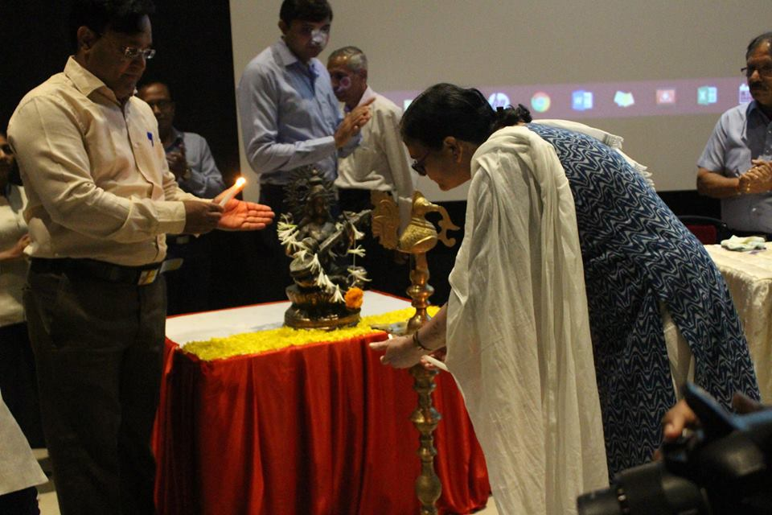
Inauguration of the workshop

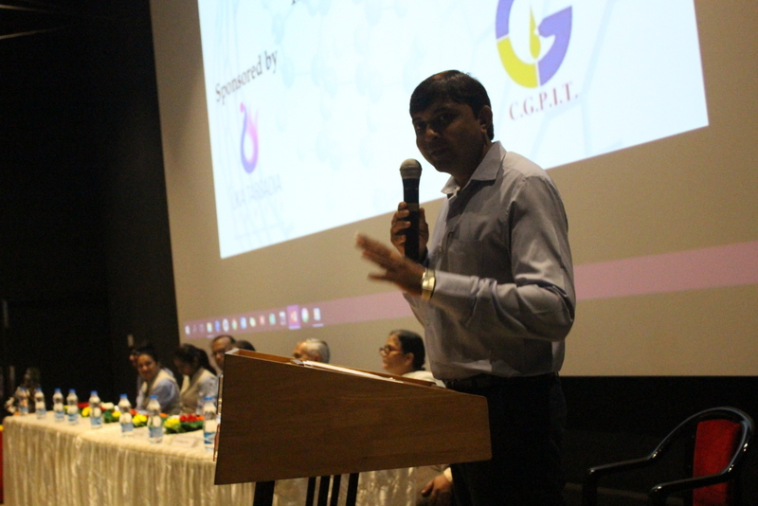
Welcome Speech by Convener
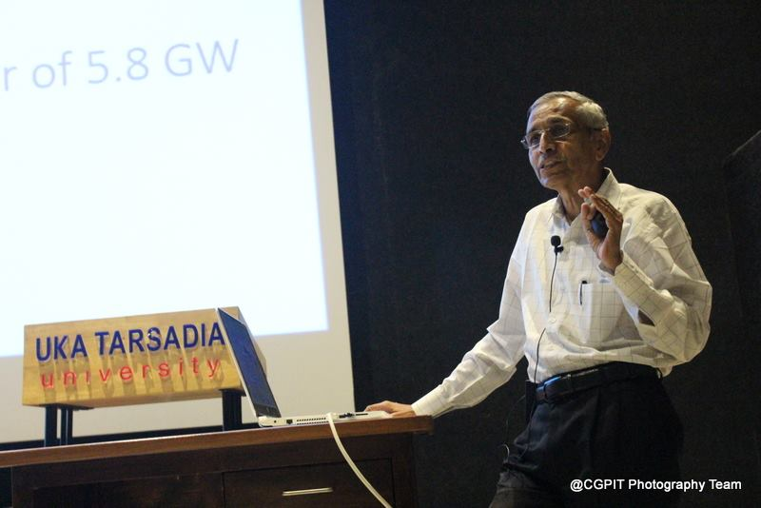
Expert Lecture –I (Dr. P. B. Joshi)
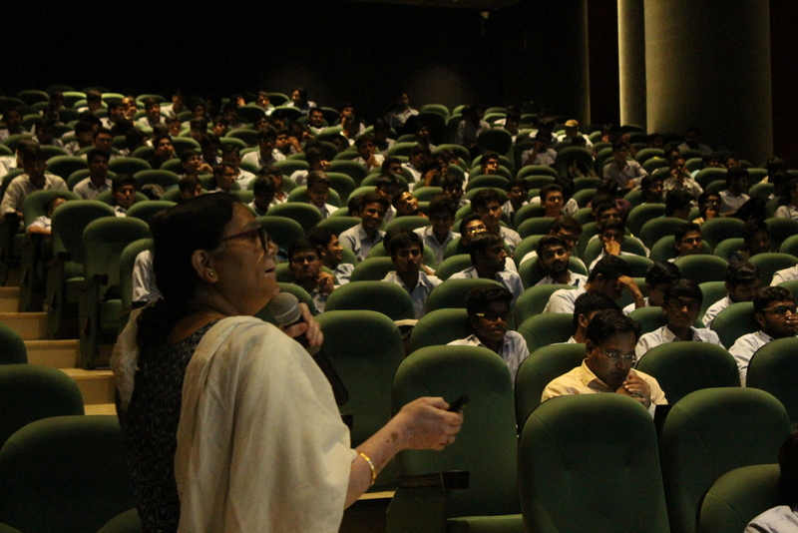
Expert Lecture –II (Dr. Vandana J. Rao)
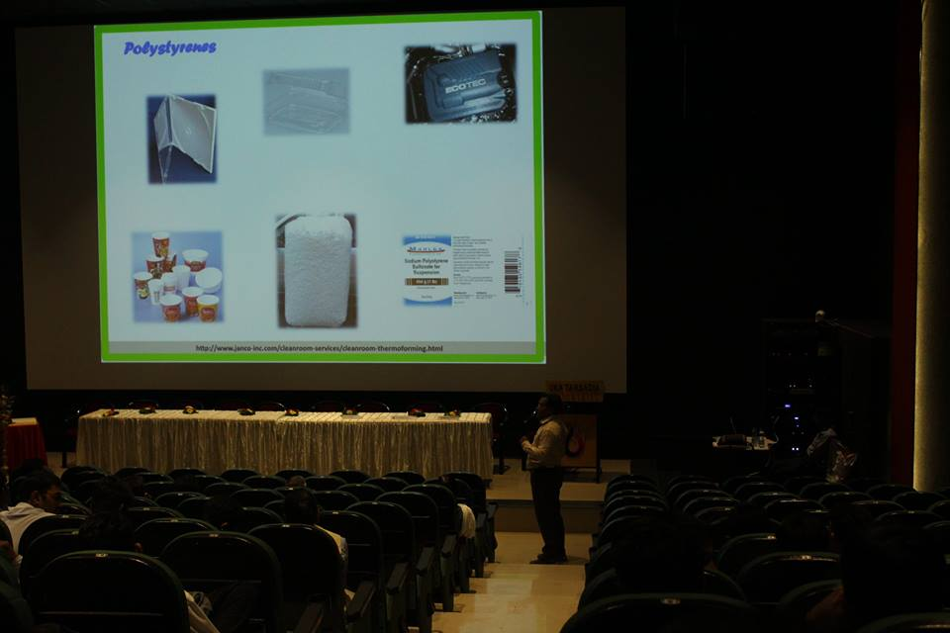
Expert Lecture –III (Dr. Rakesh Sharma)

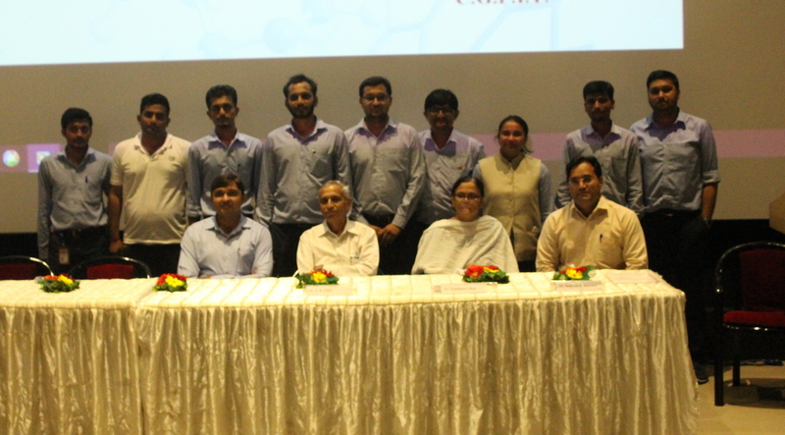
Organizing Committee of workshop

