CHHOTUBHAI GOPALBHAI PATEL INSTITUTE OF TECHNOLOGY

Department of Electrical Engineering and Mechanical/Automobile Engineering

A REPORT

ON

One day motivational seminar on
“Explore The Future As A Fresh Engineer”
Title of the Seminar | Explore The Future As A Fresh Engineer
Organizing Department | Department of Electrical Engineering  And Electronics & Communication Engineering
Chief Patron | Dr. D. R. Shah, Provost, UTU.
Patron | Dr. N. C. Shah, Director, CGPIT.
Convener | Mr. Rakesh Gajre, HOD of EC/EE Department
Organizing Secretary | Prof. Karmani Rajput  Prof. Krupa Dave  Prof. Nita Patil
Organising Committee | Prof. Darshan Vora Prof. Manish Nakrani  Prof. Ankur Rana Prof. Mayank Kapadia
Target Audience | Students of Electrical , EC and Computer Engineering
Total Number of Participants | 124
Date of Programme | 30th July, 2016
Invited Speakers | Mr. Tushar S. Bhatt, Head- Power Management , Essar Steel India Ltd., Hazira.  Mr. Mignesh Parekh, Founder and Chairman of The Kamma Incorporation, Ahmadabad.  Mr. Haresh Pandya and Mr. Rakesh Bharadwaj , Knowledge Academy , Ahmadabad.

Schedule of Seminar
30th July, 2016 Saturday

8:30 AM to 9:30 AM | Registration and Breakfast
9:30 AM to 10:00 AM | Inaugural function
10:00 AM to 11:30 PM | Expectation & Aspiration of EC/EE Industries from Budding Engineers.  Mr. Tushar Shankerlal Bhatt,  Head- Power Management , Essar Steel India Ltd., Hazira.
11:30 PM to 12:30 PM | Lunch
12:30 PM to 1:30 PM | Future in Abroad  Mr. Mignesh Parekh ,  Founder & Chairman Of The Kamma Incorporation, Ahmedabad
1:30 PM to 3:15 PM | After Degree......Government Job??????  Mr. Haresh Pandya  Knowledge Acacdemy, Ahmedabad
3:15 PM to 3:30 PM | Valedictory Function

Details of the Seminar:
Preamble:
Department of Electrical Engineering and EC Engineering, CGPIT has organized one day seminar on “Explore the Future as a Fresh Engineer” sponsored by Uka Tarsadia University. Total 124 participants participated in this motivational seminar which includes students from Electrical, EC and Computer Engineering department of CGPIT. Out of which 67 students were from EE department and 50 students were from EC department. There were 7 students from computer department also participated in the event.

The inauguration ceremony of the event was started by UTU song followed by lamp lighting and prayer to seek the blessings of almighty. As per tradition of CGPIT, all the dignitaries were given a warm welcome and were felicitated to express respect and gratitude towards them for devoting their valuable time and gracing the seminar. The dignitaries that graced the inauguration ceremony of seminar were Dr. N. C. Shah (Director, CGPIT), Mr. Tushar S. Bhatt (Head- Power Management , Essar Steel India Ltd., Hazira) and head of all the departments of CGPIT. Along with the dignitaries, our experts were also felicitated by the coordinators of the event.

Ms. Krupa Dave gave a brief introduction about the entire event. She introduced the experts and expressed her views about the importance of this seminar. The Honourable Director of CGPIT, Dr. N.C. Shah gave the welcome speech. He motivated the students and faculties for appearing in various entrance exams for government recruitment or for industrial opportunities. He also congratulated the coordinators for organizing such good motivational event. He shared his own experiences with the audience and gave nice inspiring speech.

Session Detail:

All the sessions were very interactive and laid a very good impact on the audience.
Session-1: Expectation & Aspiration of EC/EE Industries from Budding Engineers.
In this session sir had discussed industry requirements for EC and EE engineering. Mr. Tushar Shankerlal Bhatt has shared personal experience in industry.
(Mr. Tushar Shankerlal Bhatt, Head- Power Management , Essar Steel India Ltd., Hazira.)

Session-2: Future in Abroad
In this session information regarding to further study outside India was given and student had discussed different queries regarding to admission and visa process.
(Mr. Mignesh Parekh , Founder & Chairman Of The Kamma Incorporation, Ahmadabad).

Session-3: After Degree......Government Job??????
(Mr. Haresh Pandya, Knowledge Academy, Ahmedabad)
In this session scopes in government job were discussed. Different GPSC and UPSC exam patterns were discussed.
Feedback Analysis:
Feedback was collected from the participants in last session of the Seminar. The overall feedback of the seminar was very positive. Here are some of the feedbacks, which were given by participants.
- How relevant and helpful do you think it was for your future career?

- What were your key take away from this event?
  - Information regarding government job and its preparation
  - How to prepare for competitive exam like GPSC, UPSC
  - Precaution and research require before finding a job, institute programme for further study.

- How satisfied were you with the logistics?

- Which sessions did you find most helpful for your career selection?
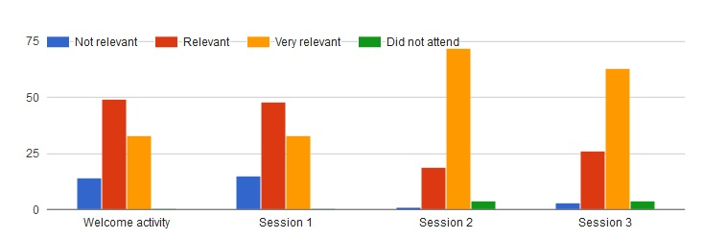
Session 1 : Expectation & Aspiration of EC/EE Industries from Budding Engineers by Mr. Tushar Shankerlal Bhatt
Session 2 : Future in Abroad by Mr. Mignesh Parekh
Session 3 : After Degree......Government Job??? by Mr. Haresh Pandya

- How satisfied were you with the session content?

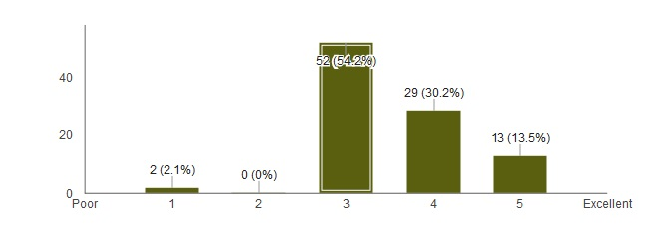
- Any additional comments regarding the sessions or overall agenda?
  - Overall good event
  - Require to arrange other events which emphasis on details of each of sessions.
- Any overall feedback for the event?
  - Majority of students gained important knowledge from the speakers.

