Chhotubhai Gopalbhai Patel Institute of Technology

Department of Chemical Engineering

Report on Industrial Visit to Ankleshwar – 2017

Chhotubhai Gopalbhai Patel Institute Of Technology, Bardoli established in 2009, have made constant efforts to upgrade the society by imparting technical knowledge to the youth and preparing them to stand in society with the attitude of competing with others and proving one’s worth in practical world.

Following its mission, the institutes have arranged an educational tour in March 2017, for the students of 4th semester Chemical Engineering to Meghmani Organics Limited at Ankleshwar.

Details of the visit are as follows:

No. of Students | 55
Faculty Members | Jitendra Kumar Singh
Visit to first plant (Pigment and Agrochemical), Meghmani Organics Ltd. | 2nd March 2017
Visit to Second Plant (Water Treatment Plant), Meghmani Organics Ltd. | 2nd March 2017

- About Meghmani Organics Ltd.:

Meghmani Organics Limited (MOL) is engaged in the manufacture and sale of Pigments and Agrochemicals. MOL carries out our manufacturing activities at four locations situated in Gujarat, India. MOL were founded in 1986 as a partnership firm, under the name M/s. Gujarat Industries, to manufacture Pigments by our Executive Chairman Mr. Jayanti Patel, together with our Managing Directors, Mr. Ashish Soparkar and Mr. Natwarlal Patel, as well as two of our Executive Directors Mr. Ramesh Patel and Mr. Anand Patel. On 2nd January 1995, our Company, Meghmani Organics Limited, was incorporated as a company with limited liability pursuant to Part IX of the Indian Companies Act. Consequent to conversion of partnership firm M/s Gujarat Industries into a company all existing assets and liabilities of the partnership firm were transferred to our Company. In 1995, we diversified into the business of Agrochemicals, by setting up an Agrochemicals manufacturing facility at Chharodi. In 1998, MOL made the product diversification by setting up Pigment manufacturing facility at Panoli. MOL specialize in green and blue pigments, which have varied end use applications including, amongst others, printing inks, plastics, rubber, paints, textiles, leather and paper. MOL manufacture pigments through our two pigment manufacturing facilities at Vatva and Panoli both of which are ISO 9001-2000 certified. Student were shown the Distribution Control Reactor Chamber and gain more knowledge.
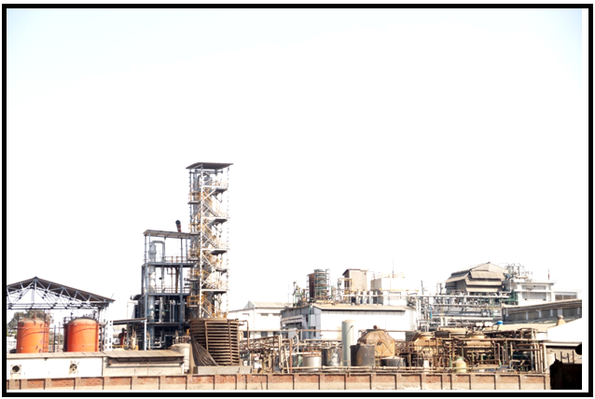
Pigment and Agrochemical plant at Meghmani Organics Ltd,Ankleshwar.
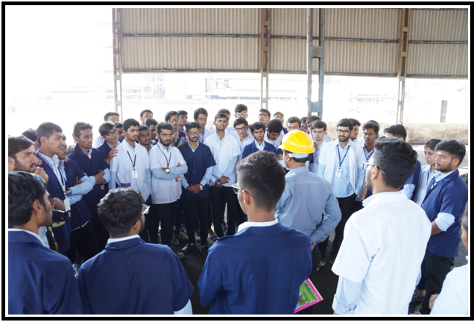
Mr. Vasant G. Patel was explaining about the working and construction of all types of Reactor
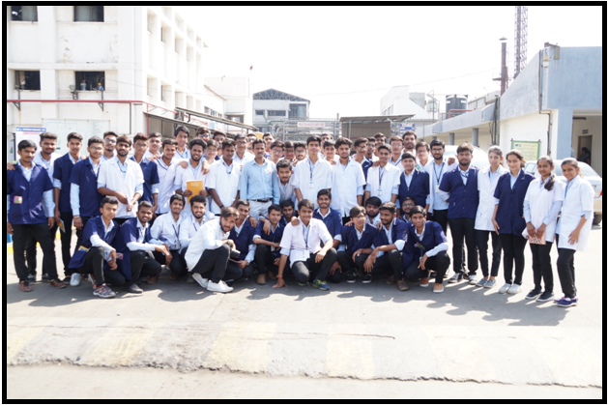
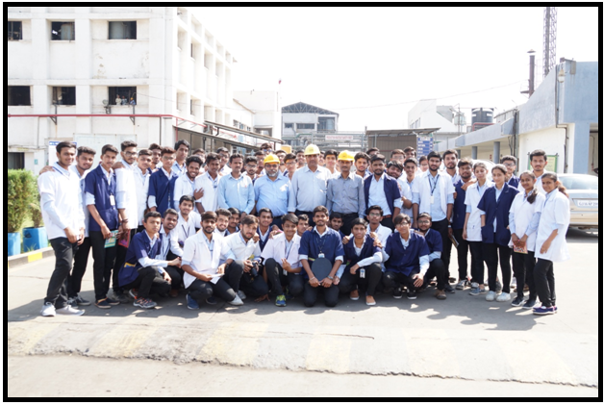
Group Photo Chemical students with MOL Technical team

- Water Treatment Plant:

Water treatment plants produce drinking water for public consumption or "industrial water" for manufacturing or other business operations. Treatment often involves some combinations of:
- Filtering out sediment and disease-causing organisms
- Chemical treatment to remove excess minerals and other contaminants
- Further settling or filtration
- Final disinfection and chemical adjustment to reduce scaling or corrosion within the delivery system

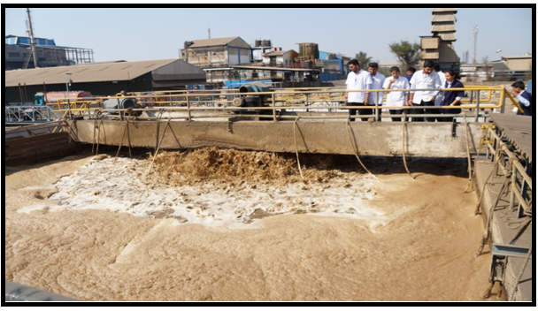
Sewage water
Water treatment plant operations often also produce wastewater that they must dispose of safely. In accordance with the federal Water Pollution Control Act and state Water Pollution Control laws, the Department of Ecology helps to ensure that the disposal of these wastewaters causes no harm to the environment.

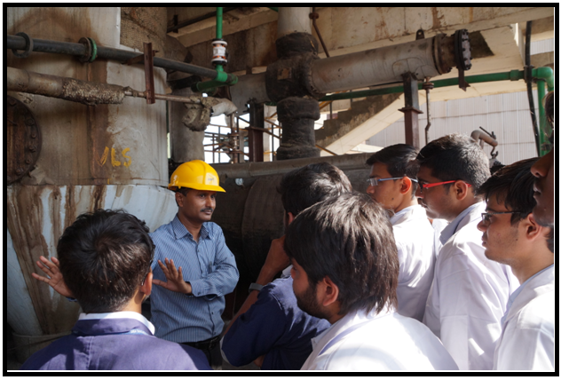
Mr. Vasant G. Patel was explaining about the working water treatment plant
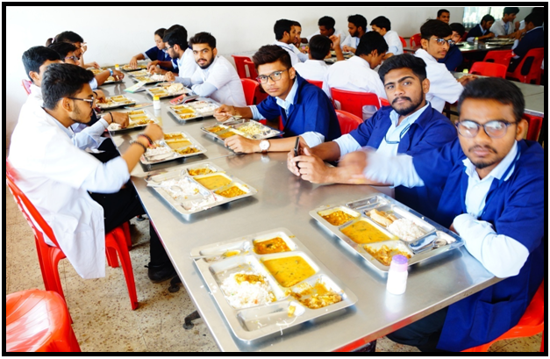
Lunch at Meghmani Organics Limited, Ankleshwar

The entire trip turned out to be a step-ahead for our students. It was a rejuvenating experience. We are very thankful to the management and Director Dr. N. C. Shah Sir for their valuable guidance. Special credit to the HOD Chemical Engineering, Dr. Chinmay Desai for arranging and coordinating such an educational and inspirational trip for students.
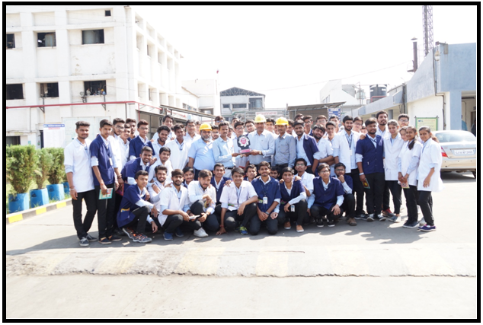
Group photo at MOL Gate

