A Report on Industrial visit to Sumul dairy, Surat.
On
13/01/2017
Organizers:
Helly Mehta, Nikita Patel, Nikahat Samnani, Parth Tandel, Runali Chheda.

Organized by:
Civil Engineering Department
Of
Chhotubhai gopalbhai Patel Institute of Technology
Uka Tarsadiea University,Malibaa Campus,Bardoli.

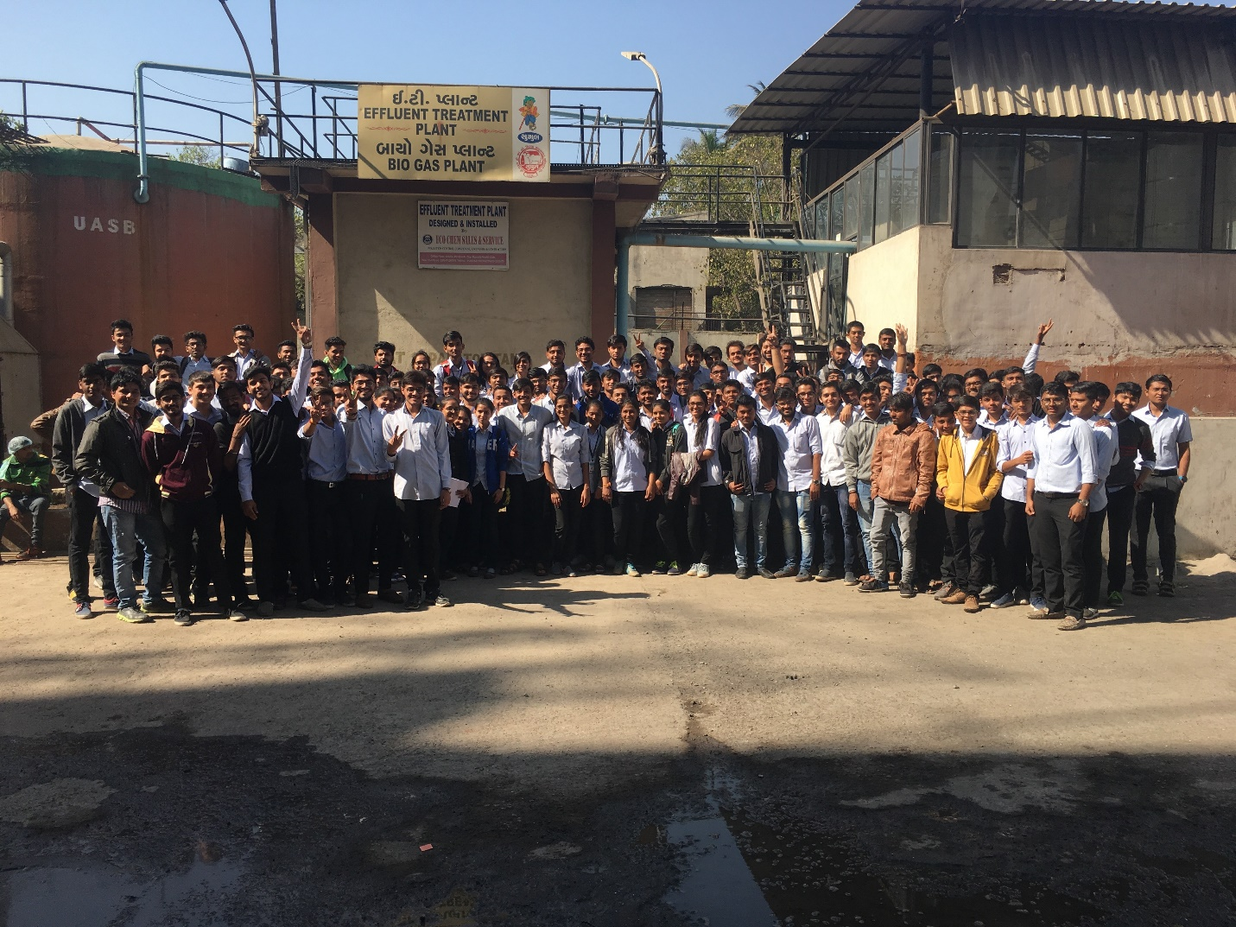
No of students taken to the visit:
Sr.No | Coarse | Semester | No. Of Students | Imparting knowledge of subject
1 | B.Tech Civil | 5th | 118 | AEE
2 | Diploma | 5th | 30 | EE
Total |  |  | 148 | -

Sumul Dairy is working on fully automatic milk producing plant producing 15 lacs liters of milk and other milk maid products per day. Along with this it is also expected that the plants working on such high capacity will also be producing waste from each units. Therefore, Students of B.Tech and Diploma 6th sem civil engineering were taken for imparting practical knowledge regarding their processes, flow variations, designs of different units and their concepts, production process and manufacturing, packaging, waste utilization and management. One day visit proved to be fruitful when the students were very much cleared about all the above said topics and guidance given by engineers working there.

