CHHOTUBHAI GOPALBHAI PATEL INSTITUTE OF TECHNOLOGY
Department of Computer Engineering and Information Technology
A REPORT ON
Two days’ Workshop on
"Introduction to Node JS and Express JS" 31st August – 1st September, 2018
Organizing Department | Department of Computer Engineering and Information Technology
Chief Patron | Dr. D. R. Shah
Patron | Dr. R. V. Patil
Convener | Ms. Purvi Tandel
Coordinators | Ms. Monali Gandhi  Ms. Supriya Pati
Target Audience | Pre Final Year Students of B. Tech. CE and B. Tech. IT
Total Number of Participants | 37
Date of Program | 31st August – 1st September, 2018
Invited Speakers | Mr. Parth Joshi, Kansffer Consulting, Surat

SCHEDULE:
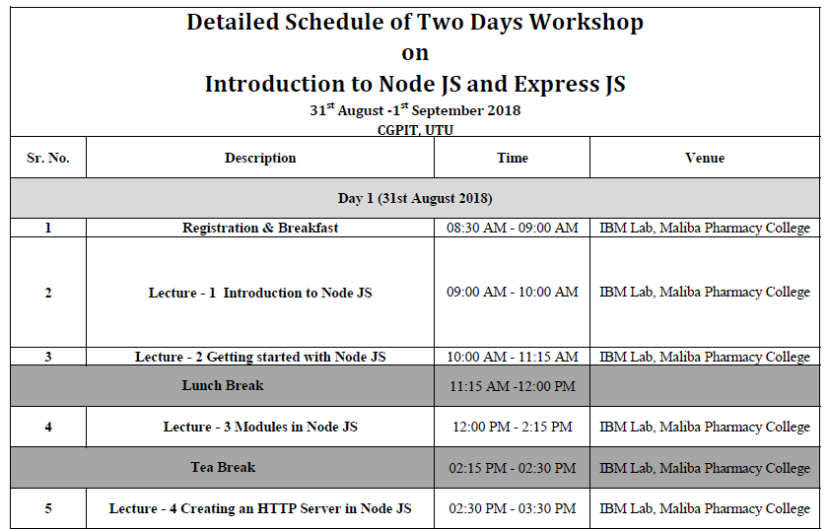
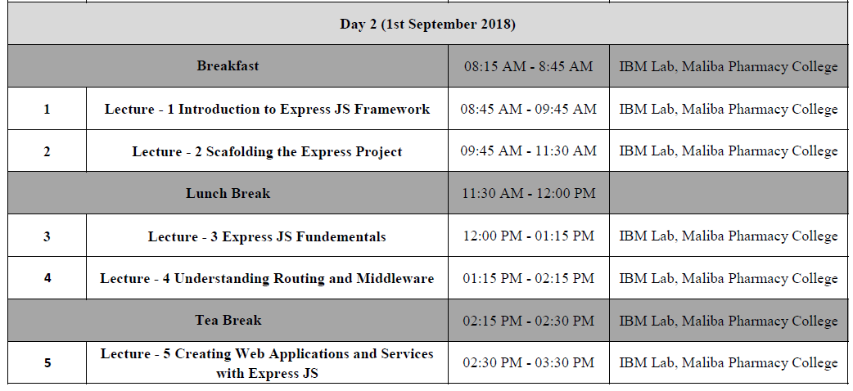
DETAILS OF THE WORKSHOP:
The workshop started with an inauguration function at IBM Lab, Maliba Pharmacy College. The head of the department were present to grace the function and welcome the expert with floral bouquet. The coordinators formally welcomed all participants and briefed regarding the workshop. Then the session started at scheduled time. Details of the same are as follows:
Day 1:
Expert of the session: Mr. Parth Joshi, Kansffer Consulting, Surat.
Mr. Parth Joshi gave basic introduction about Node JS. He explained the importance of server side scripting language and its use in technical world. He also explored different firms working on Node JS. The session was followed by installing Node JS and creating node as first project of the workshop.
After lunch break, the session was followed by exploring and creating different modules of Node JS. After tea break, participants also learnt to create an HTTP server on Node JS by creating a simple log in form. The complete session was really interactive on Day 1.
Day 2:
Expert of the session: Mr. Parth Joshi, Kansffer Consulting, Surat.
Mr. Parth Joshi started the session with introduction to Express JS Framework. The session included installation of Express JS. Participants were given a task to complete the log in form with static validation in Express JS based on which they were given points.
After lunch break, the session continued with participants exploring Express project and creating routing and middleware of the same. Expert also gave an introduction to how to use SQL in connection with Express JS project to validate Log in form details based on relational database.
Mr. Parth Joshi concluded the session with answering queries of participants and solving their doubts. The session was ended by vote of thanks and group photo session.

GLIMPSE OF THE WORKSHOP:
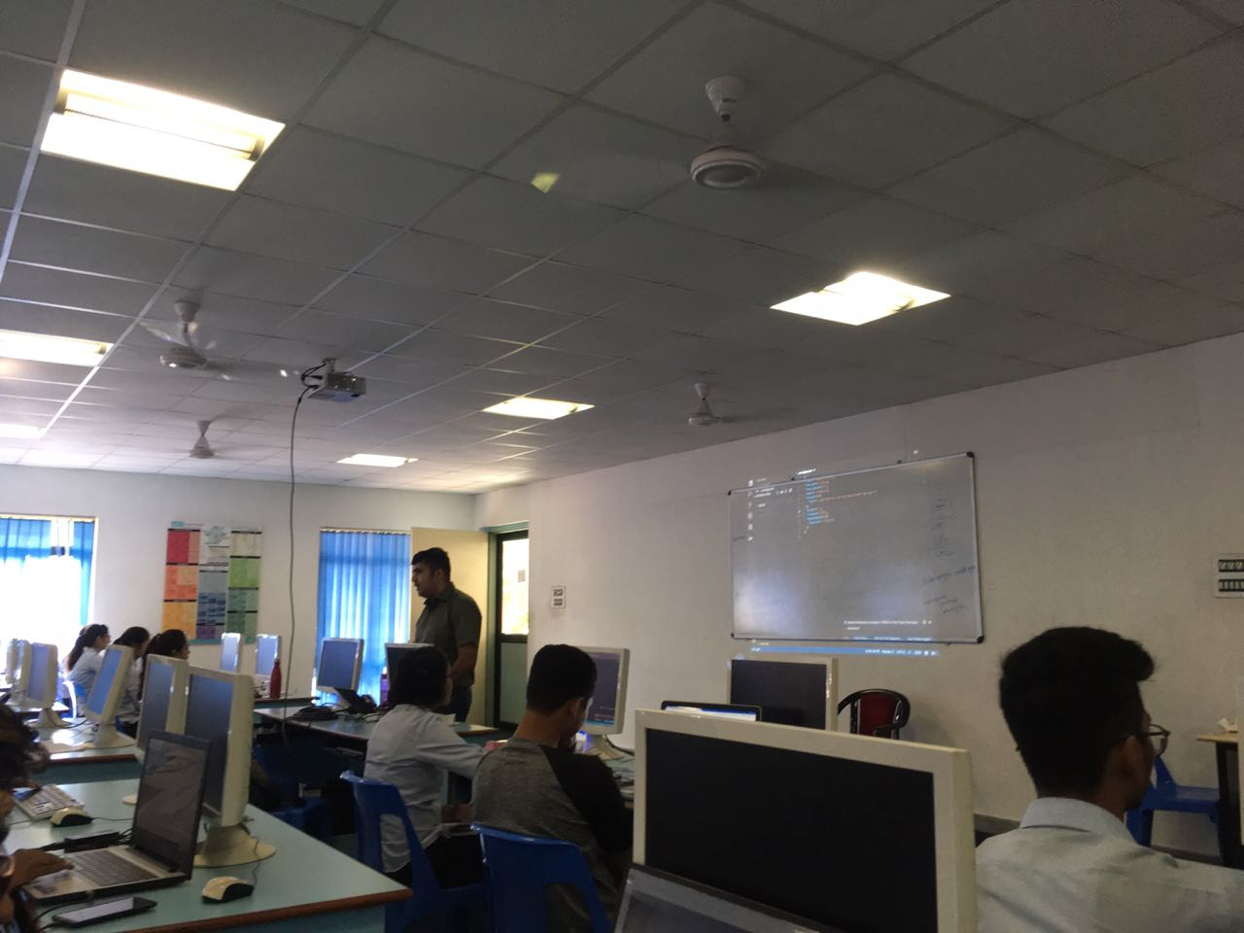
Expert Conducting the Session

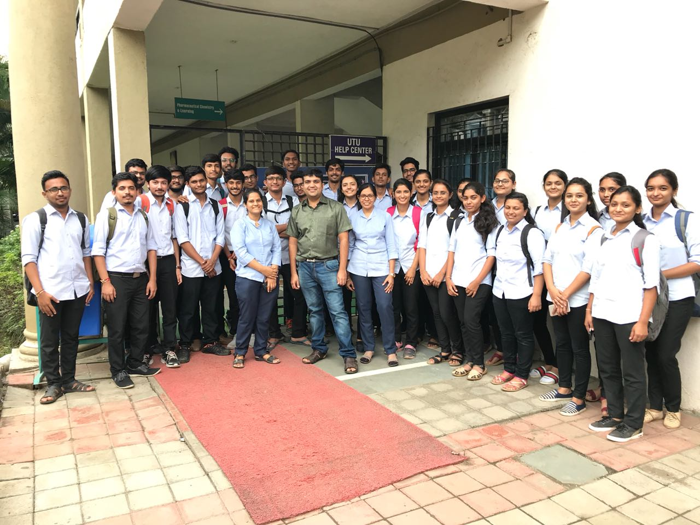
Group photo with expert, coordinators and participants
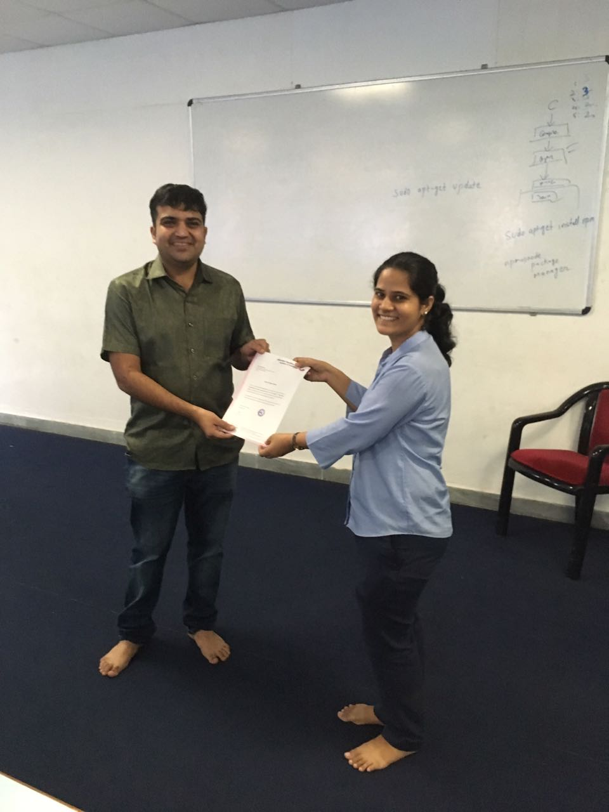
Valedictory Function

